

PART – III
COMMERCIAL BID
UNITED INDIA INSURANCE COMPANY LIMITED
VALSAD BRANCH.

SUMMARY OF WORKS

SI.NO Type of work Amount Quoted (Rs.)

- Interior Furnishing Works Rs.

- Electrical Works Rs.

- Data Cabling Works Rs.

- Air Conditioning Works Rs.

TOTAL Rs.
(inclusive of all taxes and expenses & GST etc.,)

(In words: .)

Notice: TENDERERS MUST VISIT THE SITE AND INSPECT FOR THEMSELVES THE ACTUAL WORKS TO BE CARRIED OUT BEFORE SUBMITTING THE TENDER

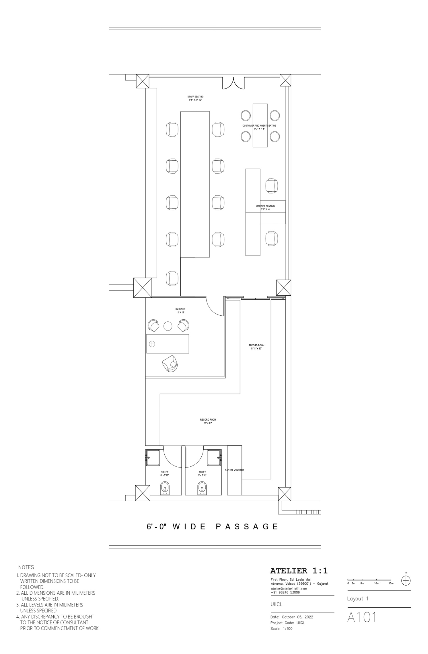
PROPOSED INTERIOR FURNISHING WORK FOR UNITED INDIA INSURANCE COMPANY LIMITED
BILL OF QUANTITIES
No | Description of Work | Size/ Quantity | Unit | Rate | Amount
1 | Full height partitions with glass panels for manager cabin :  Supplying and fixing glazed partitions using aluminium  section of size 2”x2” frame work having 2’x2’ square grid  on both sides covered with 8mm marine ply wood of  approved make and finished with 1.5mm thk lamination  which is to be used as per the drawing mentioned.  Partitions frame is to be fixed properly to the roof slab, white wood lipping with white cedar finish to be fixed to fix the 12mm thk glass with etching for full height  partition. A glazed door has to be provided as per the  drawing with door closer and locks of godrej make.(the  partitions area given below the false ceiling level cost  includes for aluminium frame to be extended and fitted up  to roof ceiling. Doors to be made out of 10mm thk glass with etching as per the design glass with etching has to be fixed on aluminium channel the bottom frame size is  6”x1½” and vertical frame size is 3’x1½” and the top  frame size is 4”x1½” the aluminium frame shall be  covered with 8mm plywood with1.5mm thk lamination  which is to be used as per the drawing mentioned the cost  include 5” brass hinges(4nos/door) and door handle as  approved by architect. | 410 | SqFt
2 | Glazed partitions with entrance door:  Supply and fixing of first class Burma teak wood Main  door frame of size 3’6”x 7’0”. Main entrance consists of  two fixed glass and two doors as per drawing. Main frame  specifications-4”x3”.Supply and fixing burma teak wood door(2nos) frame size 5”x2”side and top and 6”x2” at bottom, stainless steel 1’0” ht handles to be fixed on both  sides with door closer and lock of godrej make. 12mm  thk glass with edging is to be fixed on the door frame.  Proper teak wood lipping is to be provided to fix the  12mm thk glass. Cost includes brass hinges 5”-8Nos with  10” brass tower bolt-4Nos. All round with locker polish of approved shade and colour.2” teak wood lipping is to be  provided on outer frame all sides. Door size (3’6”X7’0”) | 490 | SqFt
3 | 100MM Thick Partition With Bothside Single Layer of Gypsum with Ply Backing  Providing & fixing 100mm thick gypsum board partitions, consisting one layer of tapered edge 12.5mm thick, 1200mm wide gypsum plaster board (conforming to IS 2095-1982) with one layer of 12.0mm thick ply on other side of GI stud, screws fixed with dry wall screws of 25mm at 300 mm centres with joints scattered, 48mm metal studs to be (0.5 mm thk. having one knurled flange of 34 mm and with joints scattered and another knurled flange of 36mm fabricated from G.l. sheets) placed in 50mm floor and ceiling channels @ 600 mm centres, floor channel fixed to concrete soleplate, and ceiling channel fixed to concrete soffit by nylon raw/ plugs @600 mm c/c including providing & fixing edge beads, corner protection angle bead, P/F hard wood frames for door frame / storages/cutting for electrical boxes etc. complete as per details given in drawing/Architect instruction. | 300 | SqFt
4 | File Cabinet in PLPB 18 mm thick all including openable shutter and shelves | 60 | SqFt
5 | Simple Table in PLPB (6X2.5) 2.5MM thick top with glass on top and rest 18 MM thick including keyboard tray, cable manager and CPU trolley | 1 | Nos
6 | Cabinet with glass opening (6x3) with PLPB in Manager's Cabin | 1 | Nos
7 | Side Table in PLPB (3X2) 25MM thick top and rest 18MM thick including openable shutter plus shelves | 3 | Nos
8 | Table in PLPB 4X2 with 1 drawer and openable shutter pedestal | 9 | Nos
9 | Table in PLPB 5X2 with 1 drawer and openable shutter pedestal | 2 | Nos
10 | High Back Chair - Aveon MB or equivalent | 1 | Nos
11 | Medium Back Chair- HOF Evoir M or equivalent – 10 Nos Revolving Pedestal, 10 Nos fixed type | 20 | Nos
12 | THREE SEATER:  Providing Soaf sets in MS, with arm rest, legs and  supportin heavy quality material in Chromimum plated  solid finish. Seats and back made of single perforated MS  sheet (16 SWG) | 1 | Nos
13 | Plastic Paint Work (FOR PARTITIONS AND INTERIOR WORK ONLY)  Preparation of all types of surfaces to be painted by removing all loose material / paint, dust, stain etc.  Supply & application of primer / putty wherever required.  Supply & application of one finish coat of Epoxy Paint / Poly Urethane Paint / Synthetic Enamel Paint of approved brand / make as per Annexure -1 on pipe lines, equipments and other metal surfaces etc.  Supply & application of Synthetic Enamel Paint of approved brand / make as per Annexure -1 on PPS fence & other as per specification and relevant item. | 600 | SqFt

PROPOSED INTERIOR FURNISHING WORK FOR UNITED INDIA INSURANCE COMPANY LIMITED
BILL OF QUANTITIES
No | Description of Work | Size/ Quantity | Unit | Rate | Amount
1 | Supply and laying of following size  of original FINOLEX PVC  insulated copper wire in suitable  PVC conduit of 2mm thk with  necessary PVC accessories like  elbows, bends etc, necessary  clampings
a | 4 x 6 sqmm + 1 x 4 sqmm from  Main MCB DB to UPS input cost of  4 x 6sqmm wire & }  1 x 4 sqmm wire }  Cost of PVC conduit pipes}  Laying/fixing charges } | 4 | M
b | BM cabin AC machine  Cost of 2 x 4 sqmm wire  1 x 1.5 sqmm wire  Cost of PVC conduit pipes  Laying/fixing charges | 7 | M
c | 2 x 4 sqmm + 1 x 2.5 sqmm  from UPS output to UPS output main  MCB DB & UPS output circuits, DBs  Cost of 2 x 4 sqmm wire }  1 x 2.5 sqmm wire }  Cost of PVC conduit pipes }  Laying/fixing charges } | 12 | M
d | 3 x 2.5 sqmm from UPS output  to circuit DBs to UPS points (four circuits)  Cost of 3 x 2.5 sqmm wire }  Cost of PVC conduit pipes }  Laying charges } | 130 | M
2 a | Supply and fixing of 2 x 4 sq.mm  and 1 x 2.5 sq.mm original  FINOLEX copper wire in PVC  conduit of 2mm thk from change  over switch to generator point | 30 | M
b | Supply and fixing of 15 A switch  plug and jacket with box (Modular  type) MK make | 5 | Nos

c | Supply and laying for 3.5 X 25  sq.mm copper cable for EB meter to  Main DB | 50 | M
3 a | Supply & fixing of HAVELL’S  make following 8way 3phase  vertical type double door MCB DBs  in suitable MS enclosures with  necessary interconnection main  MCB DB
 | MS Enclosures -1No  63Amps 4pole Isolator -1No | 1  1 | Nos  Nos
 | 25Amps 3pole MCB -3Nos | 3 | Nos
 | SP 25 Amps MCB -6Nos | 6 | Nos
b | UPS INPUT MAIN MCB DB  HAVELL’S make with MS  enclosure  40 Amps 4pole MCB | 1 | Set
c | UPS OUTPUT MAIN MCB DB  HAVELL’S make  Double door single phase 6way with
c | MS enclosure -1 | 1 | Nos
c | 40Amps 2pole MCB -1 | 1 | Nos
c | SP 10 Amps MCB -3 | 3 | Nos
4 a | Supply & fixing of HAVELL’S  make following 8way three phase  vertical type double door MCB DBs  in suitable MS enclosures with  necessary interconnection main  MCB DB for lighting
 | MS Enclosures  63 Amps 4 pole MCB | 1  1 | Nos  Nos
 | SP 10 Amps MCB | 12 | Nos
b | Change over with phase shifter  Supply & Installation of 32Amps 4  pole change over switch  for generator - (HAVELL’S make) | 1 | Nos
c | Supply & providing of indicating  lamps (3Nos) in suitable box  phase selector 3  phase(HAVELL’Smake) | 1 | Set
5 a | Supply and laying of 2pair  Telephone cable (HAVELL’S)  suitable PVC pipe/channel

 | cost of cable  cost of PVC pipe  Laying charges | 80 | M
b | Supply & installation/fixing of  Modular type RJ11 Telephone  sockets (MK make) | 3 | Nos
6 a | Supply, installation and testing of  dedicated earth pit for UPS as per  standard using 600mm x 600mm x  3mm copper thick. The rate should  include excavation, salt and charcoal  powder, brick work 450mm x  450mm, cast iron cover/plate etc of  & providing of copper plate ear  thing as per standard for dedicated  earth pit for UPS | 1 | Set
b | Supply & laying of FINOLEX  6sqmm copper wire within 20mm  GI pipe from earth electrodes to the  UPS | 30 | M
7 a | Supply & fixing of 3Nos 6amp  socket with 2Nos.6amp switch in  suitable box-Modular type-MK  make | 9 | Nos
b | Supply & fixing of 1Nos 6amp  socket with 1Nos.6amp switch in  suitable box-Modular type-MK  make | 3 | Nos
c | Supply & fixing of 2Nos 6amp | 7 | Nos
 | socket with 1Nos.15amp switch in
 | suitable box for Raw PowerModular
 | type-MK make
8 a | Supply and fixing of original
 | FINOLEX 4 x 4 sq.mm + 1 x 2.5
 | sqmm copper wire in PVC conduit
 | of 2mm thick from Main MCB DB
 | to generator change over and from
 | changeover to lighting board | 15 | M
b | Supply and fixing HAVELL’S 20A
 | Metal clad plug and socket for AC
 | Unit | 3 | Nos

9 a | Fixing of ceiling fan with
 | suspension rod. | 6 | Nos
b | Fixing of single tube light fittings | 11 | Nos
10 | Point wiring:
 | Point wiring for light,fan, 6A
 | switched sockets with (FINOLEX /
 | ANCHOR ) 2R 1.5 Sqmm FRLS
insulated multi strand single core
copper conductor wire drawn in
20mm dia 2mm thick PVC conduit
to be laid on false ceiling by
 | clamping with GI clamps, concealed
 | on wall and RCC roof etc with all
 | accessories like conduit bends,
 | junction boxes etc. The work also
 | involves supply and fixing of 6A
modular switch housed in
manufacture’s zinc passivated MS
 | box to be concealed to wall.
a | One light point controlled by one switch | 9 | Nos
b | Two light controlled by one switch | 2 | Nos
c | Fan point with fan hook | 6 | Nos
d | 6A switched socket modular type to | 30 | Nos
 | be mounted in independent location
e | Supply and installation of 2R 2.5 | 250 | M
 | Sqmm FRLS multi strand copper
 | wire drwn in 20mm PVC conduit
 | 2mm thick to be laid concealed on
 | wall between DBs and switch boxes
 | including terminations at both ends
11 | LIGHT FIXTURE :
 | (Make – Philips / Wipro / Bajaj / Pierlite )
a | Supply of commercial recessed  mounted 36W LED luminates  comprises of CRCA housing powder  coated in white the LED cluster are  PMMA diffuser uniform glare-free  light distribution suitable for  600mmx600mm coiling and  operating voltage 240V input  current 0.140 – 0.160 AMP input | -

 | wattage 33-37W
b | Supply of ISW LED down lighter | -
 | comprises of aluminium dia cast
 | housing and ring finished white
 | powder coated with high translucent
 | frosted PMMA diffuser operation
 | voltage 240V input current
 | 0.060.075 AMP input wattage
 | 14.515.5W
c | 1 X18W With Box type LED tube Light Fixture. | 11 | Nos
d | 48” Ceiling Fan of Crompton / Usha | 6 | Nos
 | / havells / Bajaj make.
e | Wall mounted Fan Crompton / Usha | -
 | / havells / Bajaj make.
f | Exhaust Fan havells / Crompton / | 1 | Nos
 | Almonard make.

PROPOSED ELECTRICAL WORK FOR UNITED INDIA INSURANCE COMPANY LIMITED
BILL OF QUANTITIES
No | Description of Work | Size/ Quantity | Unit | Rate | Amount
1 | Supply & laying of CAT 6 Data | 200 | M
 | Communication cable in 2mm thk
 | heavy duty 20mm dia PVC conduit
 | and making holes in the partitions /
 | wall all accessories as required
 | (DLink)
2 | Supply & Installation, Testing & | 20 | Set
 | Commissioning of Modular type
 | 1N0s of RJ45 Female Jack housed
 | in PVC box with suitable Face plate
 | fixing the same in the wall / partition
 | with all accessories etc as required.
3 | Supply and fixing of 1M Mounting | 19 | Set
 | CAT -6 Cord
4 | Supply and fixing of 2M Mounting | 1 | Set
 | CAT -6 Cord
5 | Supply & Installation of 24 port | - | Set
 | SWITCH
6 | Supply & Installation of 24 port | - | Set
 | CAT 6 Jack Panel
7 | Supply & Installation of 6u Wall | 1 | Set
 | mounting Server rack

PROPOSED HVAC WORK FOR UNITED INDIA INSURANCE COMPANY LIMITED
BILL OF QUANTITIES
No | Description of Work | Size/ Quantity | Unit | Rate | Amount
1 | AIR CONDITIONING WORKS
1 | Supplying of Inverter Hiwall Split Type air
1 | conditioning , installation, Testing and
1 | commissioning of indoor and outdoor split
1 | air conditioner with remote control, with 5  STAR rating units including stabilizer (Make :
1 | Everest) and necessary civil works etc, The  rate of units and is including the supply and
1 | laying of 3 mts of copper pipes with
1 | insulations, rubbers, white cements etc,
1 | MAKE: Any Recognized brand
1 | 1 Ton for BM Cabin | 1 | Nos
 | 2 Ton for Staff Seating | 1 | Nos
2 | ANCILLARY WORKS
 | Supply and laying of copper pipes with
 | rubber insulations, rubber, white cements,
 | wall concealing works, etc,
 | 1 Ton for BM Cabin | 1 | Nos
 | 2 Ton for Staff Seating | 2 | Nos
3 | Supply, installation, of Outdoor Stand with
 | necessary civil works | 3 | Nos
4 | Supply and laying of PVC Blue pipes for | 10 | M
 | water drain from the indoor units with
 | necessary wall concealing works, putty works,
 | etc

